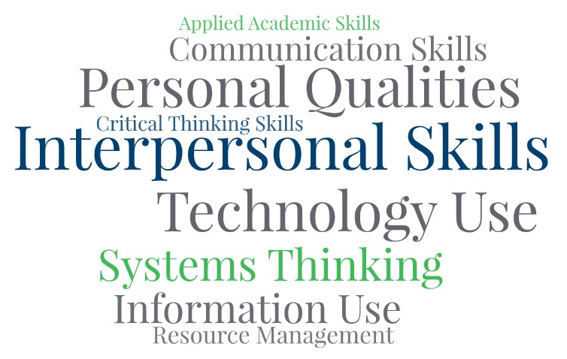

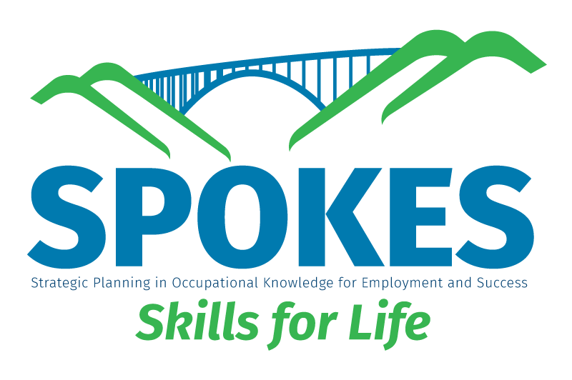
Employee Accountability
Copyright 2026
Goal Setting

All rights reserved worldwide under International and Pan-American copyright agreements. No part of this document can be reproduced, stored in a retrieval system, or transmitted in any form or by any means, electronic, mechanical, photocopying, recording, or otherwise without the prior written permission of WV Adult Basic Education.

Courseware Version: 1.0 and subsequent updates

Employee Accountability

LESSON BASICS
Lesson Topic
Employee Accountability
Standards (CCRS, GED Standard, Employability Skills Framework)
ER.PQ: Demonstrates Responsibility and Self-Discipline
ER.PQ: Works Independently
ER.PQ: Demonstrates Integrity
ER.PQ: Demonstrates Professionalism
ER.PQ: Takes Initiative

Objectives (Audience Behavior Condition Degree)
- Define employee accountability and its importance for career growth and team success
- Identify Habits of Mind (ways of thinking) that support accountability.
- Explain the benefits of accountability and recognize common barriers.
- Analyze workplace scenarios to evaluate accountability and suggest improvements.
- Reflect on personal accountability practices and create a SMART goal action plan.
Assessment
Teacher observation and learner completion of activities. Complete the rubric for each learner

LESSON MATERIALS
Handouts Needed
• Employee Accountability Rubric
• Handout #1: Habits of Mind
• Handout #2: Self-Reflection
• Handout #3: Scenarios with Guiding Questions
• Handout #4: SMART Goal Worksheet
• Handout #5: Career Planning Worksheet
• Self-Paced Learner Guide (for independent study)
• Facilitator Timing Guide (for instructors)
Online Resources

Here is the link to view the presentation:
https://doclegg05.github.io/Employee-Accountability/
Other Materials or Equipment
• Document camera or projector (optional)
• Computer/LCD projector (optional)
• Whiteboard/markers
• Pens/pencils

ACTIVITY PLAN
 | Time | Activity | Materials
Warm-up | 15 – 20 minutes | 1. Warm-Up/Review/Connections (10-15 minutes) Print and/or review the rubric with learners. The rubric outlines what areas/objectives learners will cover.  Connection Activity: Ask learners to reflect on this question:  "Think about a time when you made a mistake at work, school, or home. Did you take responsibility, or did you try to shift the blame?  How did that choice affect the outcome?"  Activity Steps:  • Give learners 2-3 minutes to think quietly  • Have learners pair-share with a partner  • Ask for 2-3 volunteers to share with the whole group  • Collect examples of accountability from various life realms: personal, family/home, school, work, community State the lesson objectives and preview what learners will accomplish
Introduction | 15 – 20 Minutes | Explain that accountability is the topic for the lesson.  Key Definitions: RESPONSIBILITY is assigned. ACCOUNTABILITY is owning the outcome.  Accountability: Taking ownership of one's actions, decisions, and performance in the workplace. When we are accountable, we don't shift blame or make excuses—we take responsibility, learn from mistakes, and focus on finding solutions.  Why Accountability Matters for Career Growth:  • Builds trust and credibility with managers, coworkers, and customers  • Demonstrates professional maturity and reliability  • Leads to greater opportunities (promotions, leadership roles)  • Encourages continuous improvement through self-reflection  Discussion Questions:  • How does someone's accountability—or lack of it—affect trust and teamwork in a workplace?  • Can you think of an example where being reliable or taking responsibility helped you (or someone you know) earn a new opportunity?
Presentation | 40 - 50 Minutes | What do you think keeps people from being accountable at work? Is it lacking caring, laziness, or preoccupation with personal issues?  "Often, what keeps us from being accountable isn't just what we do—it's how we think. The way we approach challenges, decisions, and relationships is shaped by Habits of Mind."  Habits of Mind are learned, purposeful ways of thinking that help people approach problems, make decisions, and keep learning when things get difficult or uncertain.  Distribute Handout #1: Habits of Mind Review key habits and discuss how they connect to accountability:  • Persisting – Sticking with a task even when it's hard • Managing Impulsivity – Pausing to think before acting or speaking  • Listening with Understanding and Empathy – Paying attention to others before responding  • Striving for Accuracy – Checking work carefully; setting high standards  • Taking Responsible Risks – Trying new things thoughtfully  • Remaining Open to Continuous Learning – Reflecting, seeking feedback, improving  Distribute Handout #2: Self-Reflection Have learners rate themselves on each Habit of Mind (1-5 scale).  Remind learners: This is personal. Be honest with yourself. You will be invited but not required to share.  Closing this segment: Habits of Mind strengthen accountability by helping people make thoughtful choices, take responsibility for outcomes, and learn from every experience. People who practice these habits don't blame others—they reflect, correct, and improve.  The 5 Cs of Accountability provide a framework for building responsibility:  1. CLARITY – Setting clear, specific, understandable goals, roles, and expectations. When everyone knows exactly what is expected, accountability becomes manageable and measurable.  2. COMMITMENT – Getting genuinely invested in responsibilities and organizational goals. This buy-in motivates people toward taking responsibility for their work.  3. COMMUNICATION – Ensuring expectations, progress, and feedback are shared openly and transparently. Provide constructive feedback regularly.  4. COLLABORATION – Working together effectively. When teams collaborate, they share accountability for outcomes and support each other.  5. CONSEQUENCES – Recognizing that actions have outcomes. Recognition and acknowledgment reinforce accountability; lack of follow-through undermines it.  The 6 Principles of Personal Accountability:  1. Practice Optimism – Cultivate realistic hope through challenging times  2. Practice Self-Awareness – Look at things as they really are; avoid blind spots  3. Own Your Actions – Take responsibility instead of playing the victim  4. Be Solution-Oriented – Think creatively; ask for help when needed  5. Change the Narrative – When you have facts, skills, and resources, create a new path forward 6. Supercharge Your Leadership Skills – Accept responsibility for your output
Practice | 20 – 30 Minutes | Distribute Handout #3: Scenarios with Guiding  Questions Overview: This exercise consists of workplace scenario pairs.  Each pair shows the SAME situation handled two different ways:  • Scenario A = Strong employee accountability (positive example)  • Scenario B = Weak employee accountability (negative example)  Scenario Sets Available:  • Set 1: Healthcare (Vandela Care Home / Hawk's Nest Care Haven)  • Set 2: Warehouse/Distribution (Crazy Eddie's / Dollar World)  • Set 3: Environmental Services (Hospital cleaning)  • Set 4: Welding/Fabrication  • Set 5: Medical Assistant (Pediatric Clinic)  Directions:  1. Distribute scenarios (can assign different pairs to different groups for variety)  2. Have learners read both scenarios in their assigned pair  3. Learners answer the guiding questions after each scenario  4. Circulate and facilitate small group discussions 5. Conduct whole-group debrief:  • What examples of strong accountability did you find?  • What examples of weak accountability did you find? • What could the unaccountable employees do differently?  Record key insights on the board. Connect responses back to Habits of Mind and the 5 Cs.
Evaluation | 20 – 25 Minutes | Distribute Handout #4: SMART Goal Worksheet Explain SMART Goal Criteria:  • Specific – What exactly will I do? What is the outcome?  • Measurable – How will I track progress? How will I know when it's complete?  • Achievable – Is this realistic for my skills and resources right now?  • Relevant – Why is this important to my career, education, or self-sufficiency plan?  • Time-bound – What is the target date for completion?  Activity Steps:  1. Model an example SMART goal on the board  2. Have learners choose ONE meaningful goal for the next 3-6 months  3. Allow independent work time (15-20 minutes)  4. Offer individual support as needed  5. Optional: Have learners share goals with a partner for peer feedback  Action Steps and Barrier Management: Have learners identify:  • Specific action steps to reach their goal  • Potential obstacles that might get in the way • Solutions for each obstacle  • Accountability support (who will help check on progress)
Application | 15 – 20 Minutes | Distribute Handout #5: Career and Education Planning  Worksheet Purpose: Connect what learners have learned about accountability to their career or education goals.  Worksheet Sections:  I. Core Interests & Values  • Three occupations of interest  • Skills/values that connect to these careers  II. New Skill Development Plan  • Skills needed for target occupations  • How learner will develop each skill  III. Personal Action Plan  • Connection to accountability practices  • Accountability support network  For learners with Self-Sufficiency Plans (SSP): Have them choose one goal from their SSP and connect it to accountability principles.  Bridge to Real Life: When you're personally accountable, you take ownership of what happens as a result of your choices and actions. You don't blame others or make excuses, and you do what you can to make amends when things go wrong  Wrap-Up/Concluding Activity (5-10 minutes)  Final Reflection: Ask learners to share:  • One key takeaway from today's lesson  • One thing they will do differently starting tomorrow  Closing Message: When you're personally accountable, you take ownership of what happens as a result of your choices and actions. You don't blame others or make excuses, and you do what you can to make amends when things go wrong.

Other Resources or Alternative Resources

